**RAILWAY RESERVATION SYSTEM**

**(C,DATA STRUCTURES)**

**SOURCE CODE:**

#include<stdio.h>

#include<conio.h>

#include<stdlib.h>

typedef struct node

{

int seat;

char name[15];

int age;

char sex[10];

struct node*next;

}list,*ptr;

void delet(ptr a);

void add(ptr a);

void printseat(ptr temp);

void print(ptr a);

void delet(ptr a);

int main()

{

int i,input;

ptr a;

clrscr();

a=(ptr)malloc(1*sizeof(list));

a->next=NULL;

a->seat=0;

for(i=0;i<100;i++)

{

printf(“\n*****Welcome to south Indianrailways*****”);

printf(“\n1.To book a ticket”);

printf(“\n2.for deleting a ticket”);

printf(“\n3.to print the chart”);

printf(“\n4.exit”);

printf(“\nEnter your option”);

scanf(“%d”,&input);

if(input==1)

add(a);

else if(input==2)

delet(a);

else if(input==3)

print(a)

else if(input==4)

break;

else

printf(“\nEnter correct input:”);

}

Printf(“\nThankyou”);

getch();

return 0;

}

void add (ptr a)

{

int input,input2;

ptr temp=NULL;

while(a->next!=NULL)

{

a=a->next;

}

if(a->seat->70)

{

printf(“seat not available”);

return 0;

}

else if(a->seat->50)

{

printf(“%d Waiting available\n”,(a->seat)-50);

printf(“\n Enter 1 to exit 0 to continue”);

scanf(“%d”,&input2);

{

if(input2==1)

{

return;

}

}

temp=(ptr)malloc(1*sizeof(list));

temp->next=NULL;

printf(“\nEnter name:”);

scanf(“%s”,temp->name);

printf(“\nEnter age:”);

scanf(“%d”,&temp->age);

printf(“\nEnter gender:”);

scanf(“%s”,temp->sex);

temp->seat=(a->seat)+1;

printf(“\nEnter 1 to print the ticket”);

printf(“\n 0 for not to print the ticket:\n”);

scanf(“%d”,&input);

if(input==1)

{

printseat(temp);

}

a->next=temp;

return;

}

void printseat(ptr temp)

{

if(temp->seat>50)

printf(“WL=%d”,(temp->seat )-50);

else

printf(“\nconform seat=%d”,temp->seat);

printf(“\nName=%s”,temp->name);

printf(“\ngender=%s”,temp->sex);

printf(“\nAge=%d”,temp->age);

return 0;

}

Void print(ptr a)

{

a=a->next;

while(a!=NULL)

{

printf(“\nSeat number=%d,name=%s,age=%d,gender=%s\n”,a->seat, a->name,a->age,a->sex);

a=a->next;

}

return;

}

void delet(ptr a)

{

int input;

ptr temp;

a=a->next;

printf(“\nEnter the seat number:”);

scanf(“%d”,&input);

while(a!=NULL&&(a->seat)!=input)

a=a->next;

if(a==NULL)

{

printf(“\nEnter correct seat number\n”);

return;

}

temp=a;

a=a->next;

free(temp);

while(a!=NULL)

{

a->seat=a->seat-1;

a=a->next;

}

printf(“\nSeat deleted successfully\n”);

return;

}

**OUTPUT:**

BOOKING TICKET:

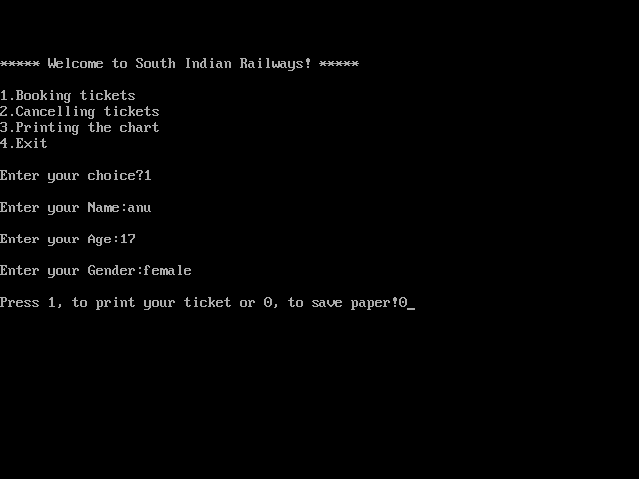

PRINTING THE CHART:

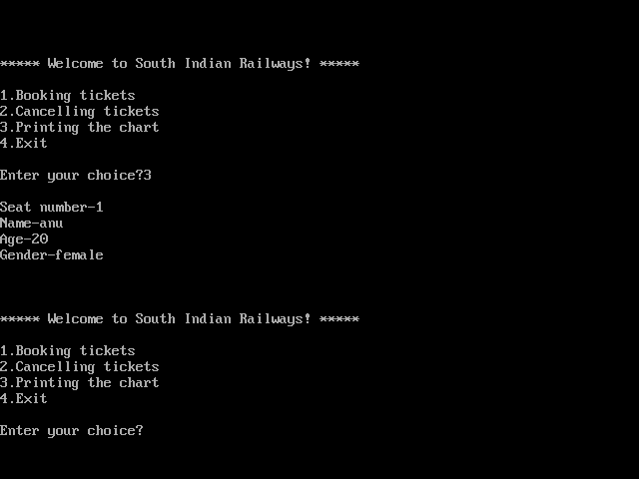

CANCELLING THE TICKET:

